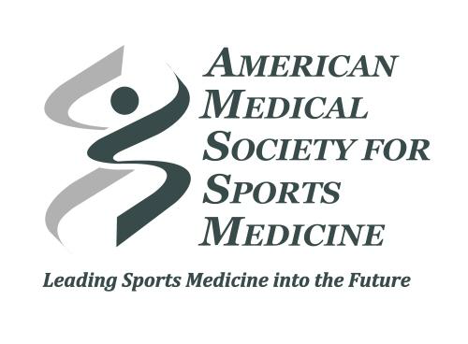
Fellowship Performance Index

This worksheet will introduce the Fellowship Performance Index tool and allow you to prepare your information before you attempt to enter your data online. We hope that review/completion of this worksheet before data entry will make the online process much easier and faster.

Data you will need:
- Patient volumes for last year’s graduates with encounters broken down by visits seen in:
  - Primary care sports medicine clinic
  - Training room
  - Continuity clinic
- Graduate Pre-test, In-Training Exam and CAQ Results
- Compilation of core faculty scholarly activity from last year (peer reviewed articles, book chapters, lectures, etc.)
- Fellow QI projects of Graduating Class
- Fellow Scholarly Activity from last year
- Audit of resident procedures
- PD experience/continuity
- Alumni survey on graduates’ scope of practice
Worksheet:
The following tables summarize the questions that you will have to answer online. This worksheet can be printed and used to fill in your answers before you enter them online.
Program Accreditation and Identifier
Current accreditation (pick one): |  |  |  | ACGME accredited | AOA program seeking ACGME accreditation | New Program not yet accredited.
Current accreditation status (pick one): | Continued accreditation | Continued Accreditation with Warning | Initial Accreditation | Initial Accreditation with Warning | Pre-Accredited (AOA Program) | Probationary Accreditation
Year of Initial Accreditation:
Type of Program (e.g. Academic vs. Community):
Number of Fellows:
Fellow(s) Specialty:
Specialty Sponsoring the Fellowship (i.e. FM, Peds, EM etc.)
Number of PCSM Faculty (Program Director + Core Faculty):
What is your ACGME or AOA Program Number? (Enter zero if you are not yet accredited by either the ACGME or AOA.)
Fellowship Patient Experience
Total # of patients seen by the fellow(s) this past year in a primary care sports medicine clinic
Total # of patients seen by the fellow(s) this past year in a training room setting
Total # of patients seen by the fellow(s) this past year in their continuity clinic/setting
Do you offer rotations in: |  |  |  | Yes/No
Knee
Shoulder
Spine
Hand
Foot/Ankle
Hip
Physical Medicine and Rehabilitation
Pediatrics
Casting
Urgent Care
Do you offer specialty rotations in: |  |  |  | Yes/No
Cardiology
Radiology
Physical therapy
Exercise physiology
Neurology
Rheumatology
Nutrition
Psychology
ABFM Board Certification
Fellow(s) Pre-test score:
Fellow(s) ITE score:
CAQ Exam score for each fellow last year (If no data available, enter zero.)
CAQ Exam first-time-pass rate in the past 5 years:
Scholarly Activity / QI
Choose one of the following answers regarding faculty scholarly work:

Not all of my core faculty have completed at least 5 presentations at national/regional meetings and/or peer-reviewed publications in the past five academic years?

All of my core faculty have completed at least 5 presentations at national/regional meetings and/or -peer-reviewed publications in the past five academic years?

All of my core faculty have completed more than 5 presentations at national/regional meetings — and/or peer-reviewed publications in the past five academic years?
% of fellows from the most recent graduating class completing scholarly activity during fellowship which was presented at a national/regional meeting or published in a peer-reviewed journal?

% of fellows from the most recent graduating class actively participating on a QI team utilizing functional strategies and framework, such as PDSA, in completing and sustaining at least one improvement project during fellowship.
* Procedures from Last Year’s Graduating Class | Total Number (each fellow) | Fellow(s) have been deemed to have:  a) An exposure to this procedure/test  b) Are competent and can perform independently  c) None of the above
Number of diagnostic ultrasound scans performed
Number of interventional ultrasound scans performed
Number of athlete ECG’s reviewed
Number of neuropsychological tests interpreted
Fracture management
Treadmill stress testing for cardiac screening
Cardiopulmonary exercise testing
Biomechanical analysis
Bike fit
Inspiratory training
Orthotic fitting/manufacture
Dietary analysis
Glenohumeral joint injection
Subacromial injection
Knee joint injection
Hip joint injection
Exercise Prescriptions
* Not all fellowships will have completed all of the listed procedures. This list is also not meant to be exhaustive of all that is done during fellowship year.

For the procedural training offered in your program, residents are evaluated using a validated competency assessment tool (pick one): | For all procedures | For some procedures | Never

Interpersonal Skills and Practice Management
Does the program routinely perform chart audits on the fellows to assess their ability to communicate and bill/code effectively (Yes/No)?

Program Director Experience
# years as a Program Director

Program Leadership Stability
# Program Directors in the last 10 years in your program

Residency graduates’ scope of practice in past 5 graduating class years

% of grads that work in an orthopedic practice

% of grads that serve as faculty in a residency

% of grads that serve as faculty for a sports medicine fellowship

% of grads work in student health

% of grads that are team physicians for a high school

% of grads that are team physicians for a college

% of grads that perform inpatient medicine

